**A Lottery Website with Web3 Wallets**

**Documentation**

**Total 100% Dividetion:**

100% of total lottery

48% will go as prize money.

23% will go to generational income.

5% will receiveTop 10 sellers. Change: top bayer 30 jon

10% Premium members receive.

The remaining % will go to the main account.

**Frontend:**

**Website: Website Name:** [**www.lottaverse.io**](http://www.lottaverse.io/)

[Design idea from <https://lottoday.io/> images are releted design wich is includ ball]

Header Menu: HOME, PRICING, HOW IT WORKS, WINNER, AFFILIATES

Header Button : Connect Wallet { main header }

**Sign-Up/Registration:**

Users can sign up in one ways. The way is an anonymous way. Users can just add any web3 wallet and they will have successfully created an account. Though, in the first way or web2 registered users also have to add a wallet to transact.

#. When Click connect wallet Button Then **open new window App.lottaverse.io** then sign in with wallet address otherwise register with wallet address.

#. When Click Connect Wallet Button Then open the pop for login by the wallet as like:-

1. Metamask

2. Trust Waller

3. BNB

After log in or register it will go to app.lottaverse.io as subdomain. Change: login korar por direct jabe dashboard a

**Pricing: The lottery will have three packages**

There will be three types of lottery packages:

**Easy Package**

$ 3 / Per Ticket

**Jackpot Icnlude**

First Winner Will Get $3000

Second Winner Will Get $1000

Third Winner Will Get $300

1000 Lucky Winner Will Get $10

**Super Package**

$ 5 / Per Ticket

**Jackpot Icnlude**

First Winner Will Get $5000

Second Winner Will Get $1500

Third Winner Will Get $500

1000 Lucky Winner Will Get $15

**Super-X Package**

$ 10 / Per Ticket

**Jackpot Icnlude**

First Winner Will Get $10000

Second Winner Will Get $3000

Third Winner Will Get $1000

1000 Lucky Winner Will Get $30

There will be a draw if 10,000 tickets are sold from each package.

Each package will have a random ticket selection system and one-way ticket selection system at a time.

**WINNER:**

There will be a history of the user and the jackpot amount of the last lottery winner. And there will be a search field where the user will show his winning history if he search with his lottery ticket number.and the latest history will be posted here

**HOW IT WORKS:**

Here are the details of how the lottery works.

**AFFILIATES**

Clicking on the AFFILIATES menu will take you to the login and affiliate page where the details of AFFILIATES will be there. Before registering one clicks on AFFILIATES which takes one go to the registration page/ connect wallet page.

**Our Services or Lottery refferel system:**

Our service is lottery package sale. Our selling system will be on unilevel system

Create a system where when a user clicks on a previous user's referral link during registration, that user's referral link is automatically populated in a field called Sponsor field on the registration form.

And in unilevel system, commission is distributed up to 7 generations or levels. Which will be through referral system. And the commission will go to the user's personal wallet for the referrer's income.

The commission between generations or levels will be as follows:

Level-1 : 10%

Level-2 : 5%

Level-3 : 3%

Level-4 : 2%

Level-5 : 1%

Level-6 : 1%

Level-7 : 1%

**Dashboard:**

**Our Services:**

|  |  |  |  |  |
| --- | --- | --- | --- | --- |
| **deshboard** | **View ticket** | | | |
| **My profile** | **package** | **Ticket number** | **Ticket price** | **Purches date** |
| **My earning** |  |  |  |  |
| **My team** |
| **Our Service**   1. **View ticket** 2. Buy ticket 3. Result 4. winner |
| **Wallet** |
| **Leaderboard** |

**Our Services:**

|  |  |  |
| --- | --- | --- |
| **deshboard** |  | |
| **My profile** |  |  |
| **My earning** | superx  super  easy |
| **My team** |
| **Our Service**   1. View ticket 2. **Buy ticket** 3. Result 4. winner |
| **Wallet** |

**Change: add hobe result ar winner field**

**Result field : cruuent draw hawa winner ra akane show korbe**

1. **1, 2, 3 winner**
2. **4 winner + when click 4winner button then show 1003 winner**

**Winner: ai field a show korbe sob winner .** [**https://www.littledraw.com/previousdrawdetails/216**](https://www.littledraw.com/previousdrawdetails/216) **winner page ar design sample ai link ar moto hobe . depence on our query :**

1. **Round wise**
2. **Package wise**
3. **Winner history with ticket number of 1003**

**Change : but ticket hobe lottoday.io ar moto , ticket jeneration hobe arithmetic number hisabe . ar ticket select korb lottotoday ar moto kore . randomly select thakbe, manual select thakbe.**

It will open after login with wallet address.

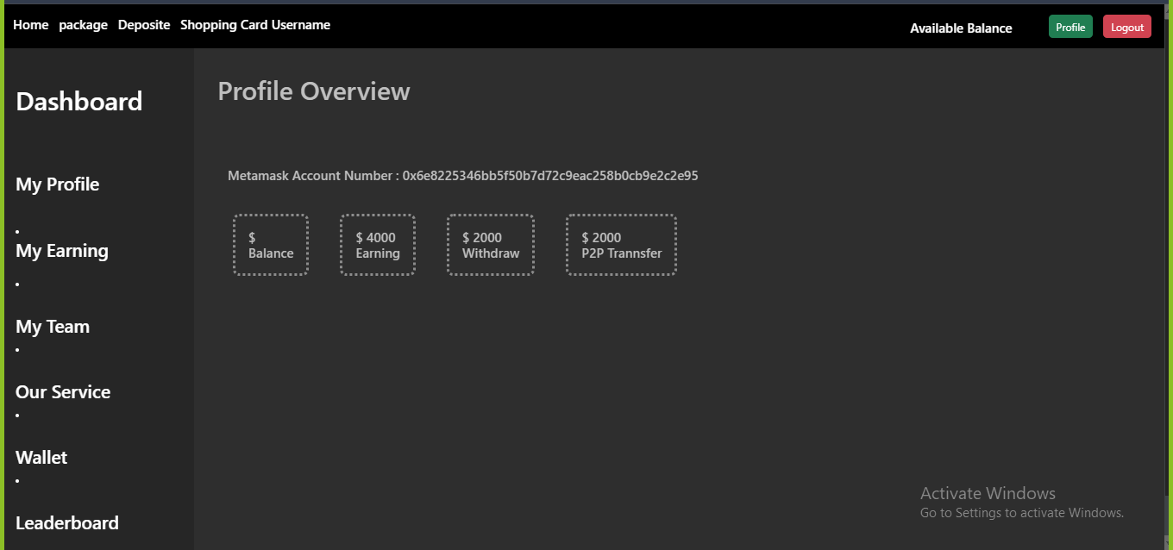

Change: login korar por jabe dashboard

My profile change : metamask account number, user type, active inactive sign thakbe, jodi active thake tahole green tic or else red cross, my profile a thakebe metamask account number, expire date, abailable balance, total earning, pay out,

My account:

It will show the user info and edit option.

My Earning:

It will show all the income with a dropdown and sub dropdown menu

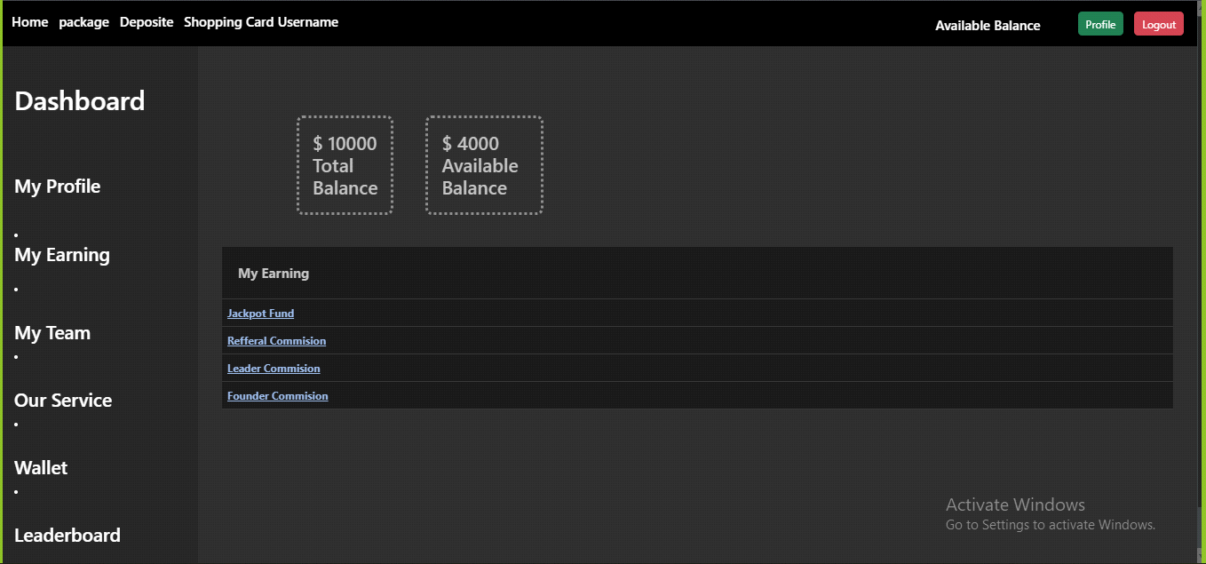

.

Change : add hobe squer shap pay out , jackpot fund , referral commition , leader bonus, founder bonus

My Team:

It will show all generations and the referred account by the user with a dropdown menu.

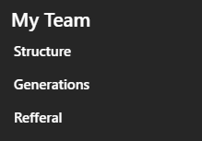

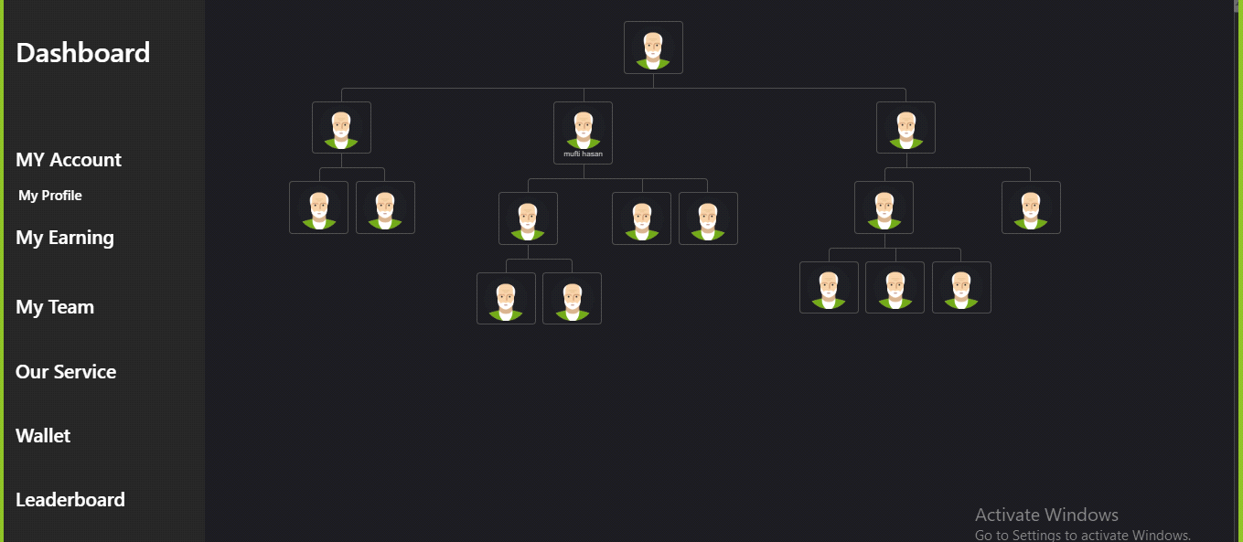

Change : structure metamask account ar firet 4 digit and – last 4 digit photo ar niche show korbe

Generations:

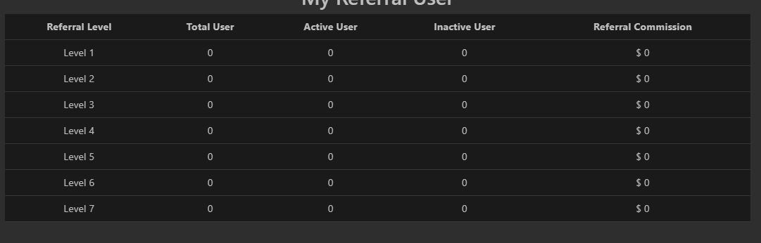

Change : level ar font sige hobe Heder ar moto

My Wallet:

It will show Deposit withdrawals and P2P transfer.

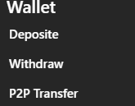

Wallet :

It will show the balance statement. There will be a table with all months name and dropdown system.Deposite , Withdraw, P2P Transfer.

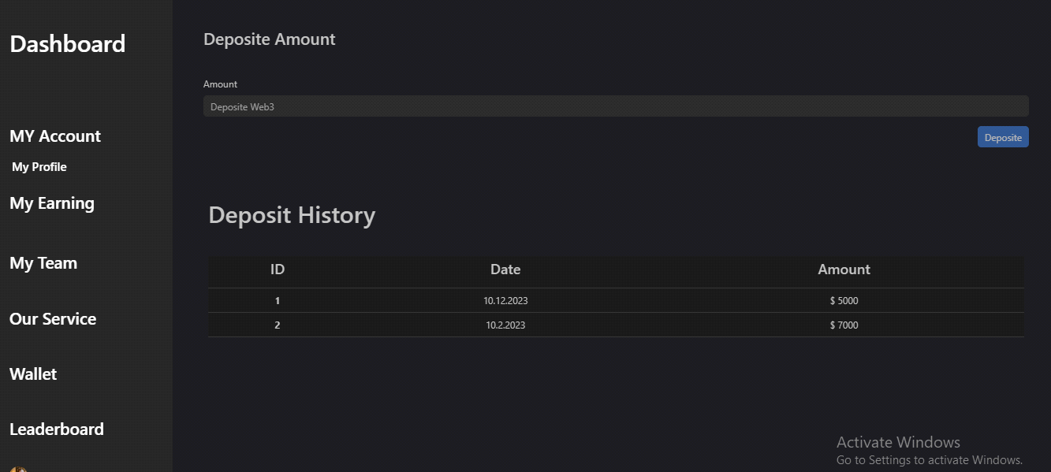

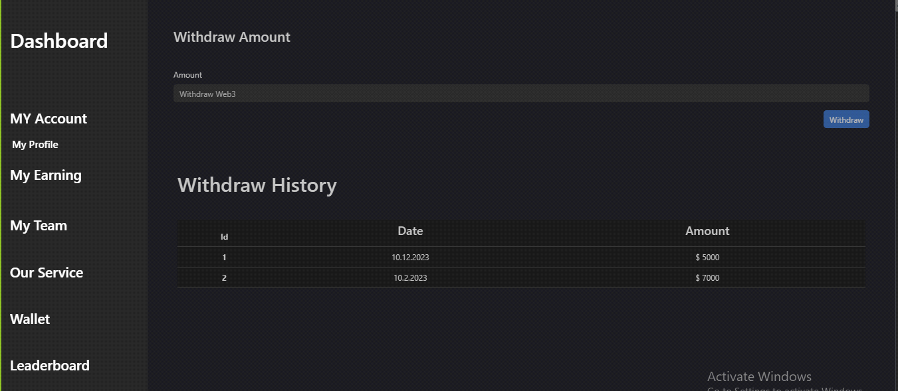

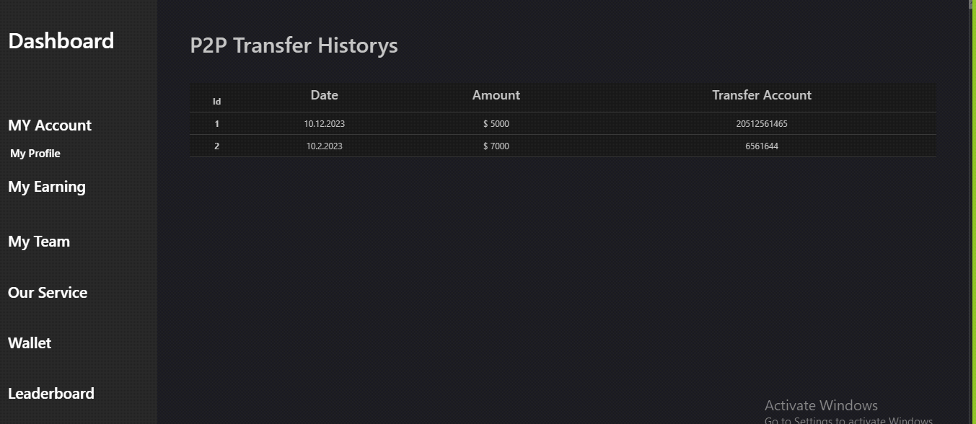

Change : add hobe jai user ar kase balance transfer hoice oi user ar wallet public address

Leaderboard:



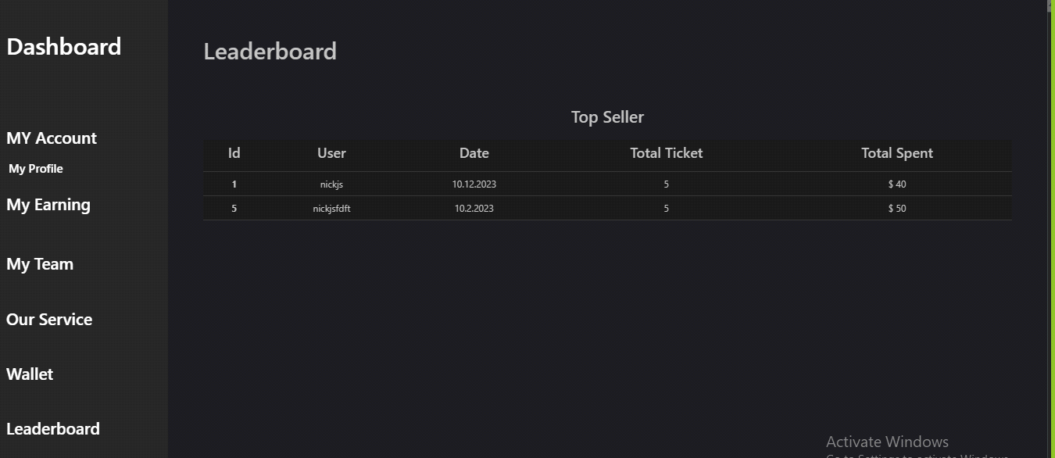

Change : 30 jon top ticket purches kora user . per manth wise change hobe

This will show the last 9 winners of the first 3 prizes of the 3 products of the last round.

**Admin Dashboard:**

Premium making Feature:

Dark and Light Theme:

**Products:**

|  |  |  |  |  |  |
| --- | --- | --- | --- | --- | --- |
| Product Name | Price | 1st Prize | 2nd Prize | 3rd Prize | 1000 of 4th Prizes |
| Easy | 3 | 3000 | 1000 | 300 | 10 |
| Super | 5 | 5000 | 1500 | 500 | 15 |
| Super-x | 10 | 10000 | 3000 | 1000 | 30 |

**Features:**

Active User:

The condition to remain active is to buy at least one ticket within the last 30 days.

Referral System:

This is a website where you can buy lottery tickets. If you tell your friends about the website and they buy tickets, you will get some money. If your friends tell their friends about the website and they buy tickets, you will also get some money. You can get money from up to 7 levels of friends. The more people who buy tickets, the more money you can get. The amount of money you get depends on which level your friend is on. Here’s how much money you can get from each level:

Level 1: 10%

Level 2: 5%

Level 3: 3%

Level 4: 2%

Level 5: 1%

Level 6: 1%

Level 7: 1%

So if your friend buys a ticket for $10, you could get $1.00 if they’re on level 1, $0.50 if they’re on level 2, and so on.

(This is a lottery website that uses a compensation plan called “unilevel”. In this plan, people who refer others to the website will earn a commission from the tickets purchased by their referrals. Additionally, referrers will also earn a commission from the referrals of their direct referrals. This means that the referrer will earn a commission from up to 7 levels of referrals down the line. The total commission earned by the referrer will be 25% of the price of the purchased ticket or lottery.)

Ticket Number:

After clicking on a product, it will open a popup window to choose how many tickets the user wants to generate. The limit will be 10 at once. All the ticket numbers will be unique and randomly generated.

Cart:

From the randomly generated tickets window, users can click “add to cart” with the tickets. Then the ticket numbers will be saved in the cart. Then in the cart window, users can either purchase or cancel a few tickets from the cart. The cart will hold data for 24 hours.

Search:

Anyone can search a ticket number and its owner address and the prize.

**Incomes:**

Prize Income: Mentioned at products table.

Referral Income:

|  |  |
| --- | --- |
| Level | Income |
| 1 | 10% |
| 2 | 5% |
| 3 | 3% |
| 4 | 2% |
| 5 | 1% |
| 6 | 1% |
| 7 | 1% |

Top Saler10/Leaderboard Income:

10 Users who accrued the highest referral income in the last week will remain in the leaderboard for a week. Each leader will earn 5% of the total ticket sold in that week. So, a total 5% of the ticket price will go to the top 10 saller/leaders.

**Premium Member Income:**

Premium users will be created/created by admin. This income section will be hidden from all other users. And you can see the CD Premium Member on the Premium Member Dashboard. Each premium member will earn 10% equally from all tickets. So, the more premium users, the lower the premium income individually.

**Transactions:**

Wallet:

Users can add any one wallet from Metamsask or Binance or Trustwallet.

Withdraw:

Users can withdraw dollars from the account to their wallets if they are active. And another condition is it has to be a minimum $10.

Two factor authentication system will be needed./ Any good authentication.

P2P:

Users can transfer balances among themselves with the same withdrawal criterias.

Pending Income:

Referral, Premium and Leaderboard income will be pending until the rounds of the tickets are over.

Admin withdraw:

Admin has to have a central wallet/account. Here he can not deposit or withdraw. He can only transfer to another account of his and then he can withdraw from that account. So, the admin needs a central and another account to withdraw.

**Requirements:{what'sapp +8801712347288}**